Effects of the Compression Strategy on Language Complexity Metrics
Rui Emanuel Lima Vieira¹
Felipe Ribas Serras²
Marcelo Finger²
Institute of Math and Computer Sciences¹ and Institute of Mathematics and Statistics², University of São Paulo
ruiemanuelvieira@usp.br

Objectives
Measuring linguistic complexity remains one of the major open challenges in linguistic typology. The enormous diversity of languages worldwide demands a quantification method that is objective, consistent, and robust across diverse language families, reducing subjectivity and evaluation biases. Among the proposed approaches, one that has gained popularity is based on computational compression (Juola 2008). This method is derived from Information Theory and aligns with a teleological view of language, in which linguistic dynamics are characterized in terms of the purpose of communication and transmission of information, which can be computationally measured—or approximated—in bits using data compression techniques.
This research investigates the validity and robustness of this approach, comparing the performance of different compressors and different strategies for data compression and complexity estimation, extending results beyond the compression methods tested in the original works. We conducted experiments on a large corpus of 50 languages, including both Indo-European and South American Indigenous languages such as Yanomami and Guarani. This variation is important to test the robustness and consistency of the algorithms against linguistic diversity.
Our objective, therefore, was to evaluate the robustness of the family of linguistic complexity metrics proposed by Juola (2008), implemented across different compression algorithms, in relation to a diverse linguistic sample, examining their consistency and agreement, especially concerning baseline hypotheses about cross-linguistic complexity behavior.

Materials and Methods

IWe evaluated compression-based linguistic complexity metrics in 51 South American Indigenous languages and several Indo-European control languages (Ancient Greek, English, French, German, Portuguese, and Spanish). We applied the metrics proposed by Juola (2008) and Ehret & Szmrecsanyi (2016), which calculate overall and tier-specific complexity (morphological, syntactic, pragmatic) by comparing the byte size of compressed texts with degraded versions, where the degradation selectively disrupted information transmission at each linguistic level. Degradation was performed through random removal of characters, words, and verses, applied to passages from the Catholic New Testament, chosen for its broad availability of translations.
The texts were normalized and converted to UTF-16, with outliers such as Nambikuára removed due to tonal markings. Two subsets were created: Dall (verses present in all languages) and D90 (languages containing at least 90% of the verses). In each case, we tested gzip, bzip2, zpaq, and bsc, each employing different compression strategies. The experimental setup and base library followed Serras et al. (2024).

Results
Following these procedures, we observed several hypotheses already reported in the literature. Among them, we verified the existence of a trade-off between morphological and syntactic complexity, regardless of the compressor used. As shown in Picture 1: (i) there is a negative correlation between these two metrics, and (ii) similar clustering patterns across the data emerge consistently between compressors.

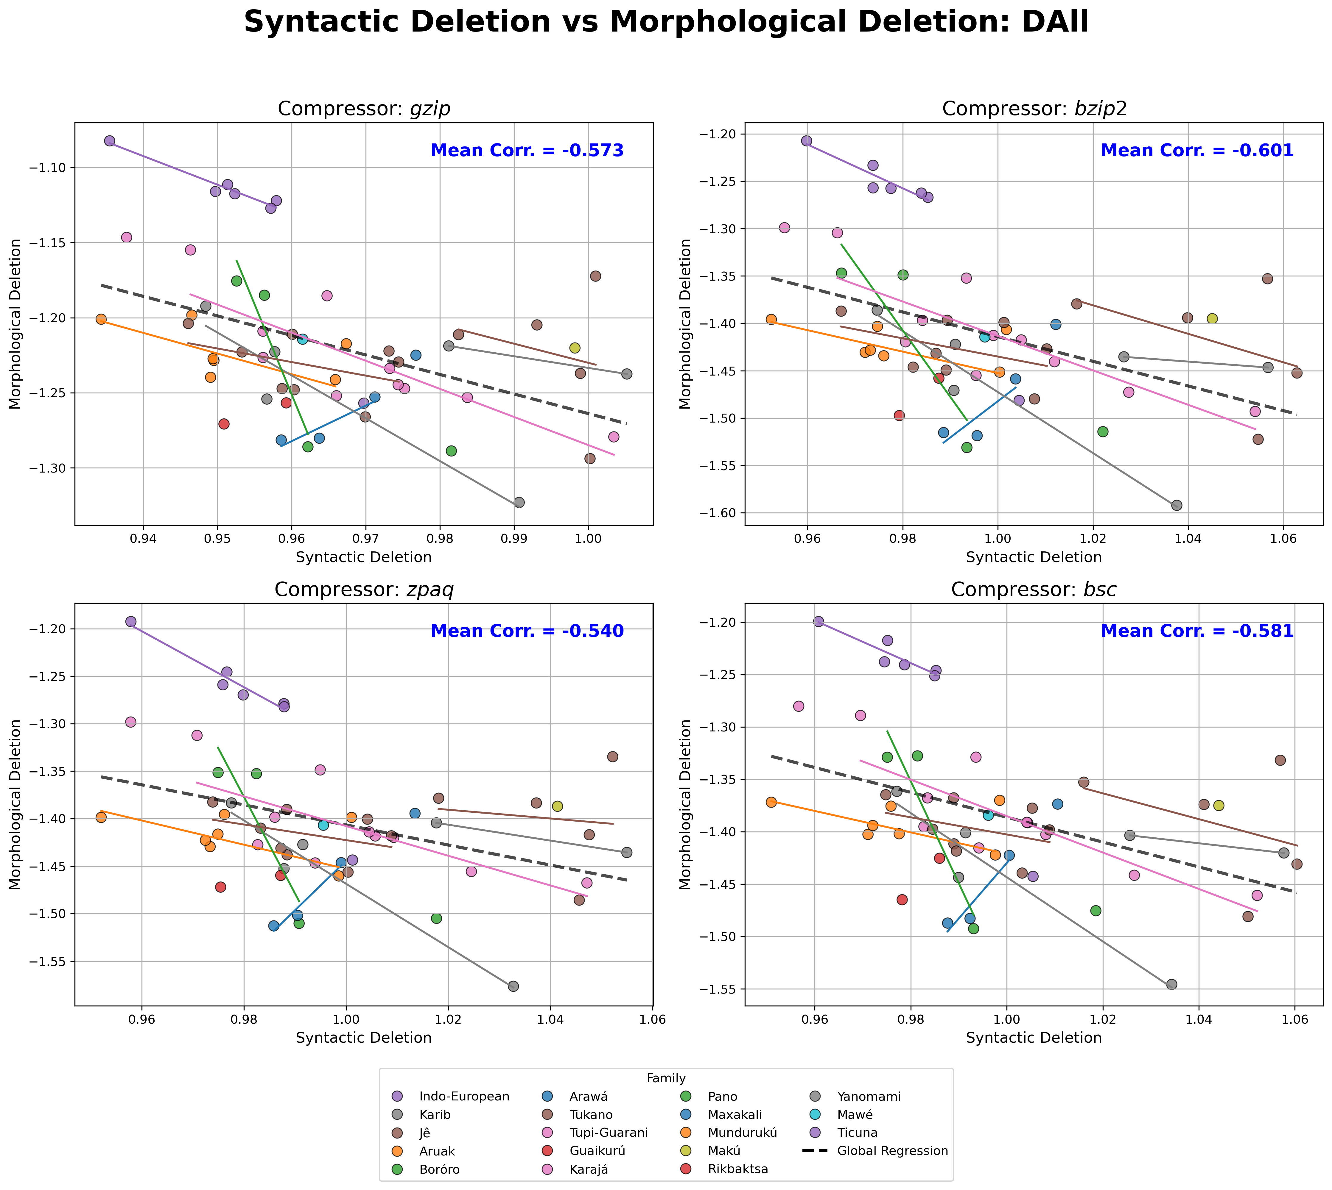
Picture 1: Graph of the DALL subset comparing morphological and syntactic complexity across different compressors.
Conclusions
The results confirm the robustness of compression-based complexity metrics, showing that different compressors yield consistent results. The trade-off between morphological and syntactic complexities was clearly identified.

Acknowledgements
This work was developed at the Center for Artificial Intelligence (C4AI-USP), with support from FAPESP (FAPESP grant #2019/07665-4) and IBM Corporation. Partial support: FAPESP (#2023/00488-5, #2022/11254-2), CNPq 302963/2022-7 (PQ), Ministry of Science, Technology and Innovation (Law No. 8.248, of 23/10/1991, PPI-SOFTEX program, coordinated by Softex and published in TIC 13, DOU 01245.010222/2022-44). IBM scholarships managed by FUSP (3541) and PPI-SOFTEX scholarship managed by FUSP (3970).
References
- Katharina Ehret and Benedikt Szmrecsanyi. 2016. An information-theoretic approach to assess linguistic complexity, pages 71–94.
- Patrick Juola. 2008. Assessing linguistic complexity.
- Felipe Serras, Miguel Carpi, Matheus Branco, and Marcelo Finger. 2024. Analysing and Validating Language Complexity Metrics Across South American Indigenous Languages. In Proceedings of the Workshop on Cognitive Modeling and Computational Linguistics, pages 152–165, Bangkok, Thailand. Association for Computational Linguistics.

